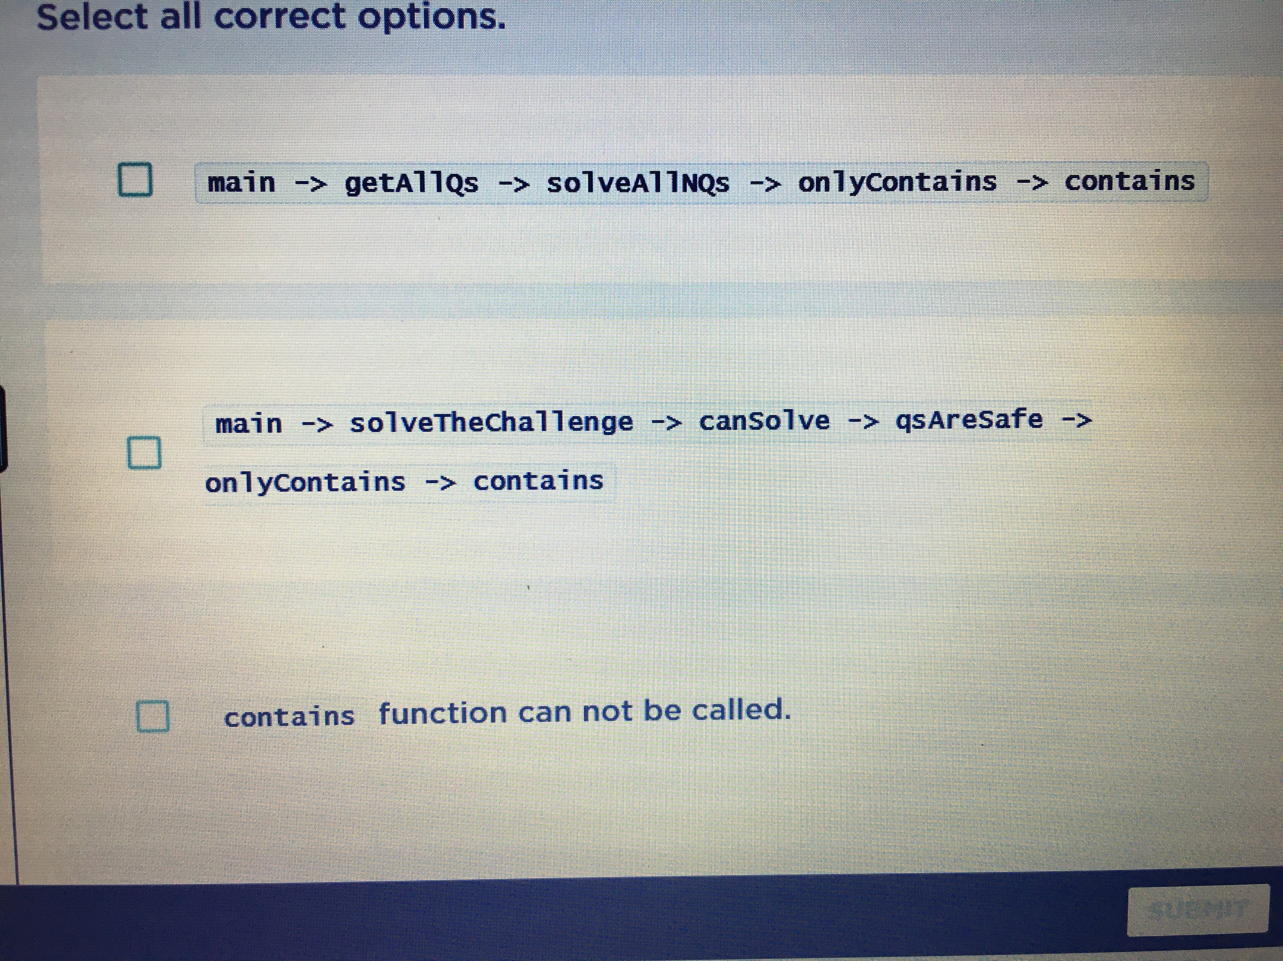

ewrwr|weq|ewrq

# About Me

# Work Experience

**re** *we-wqe*re

**fdgh** *jr-hj*jh

# Skills

-sdfdfdsf

-ggfhd

-gfdhyg